JOB PORTAL SYSTEM

1. TABLE OF CONTENT
2. INTRODUCTION

2.1 PURPOSE

2.2 SCOPE

2.3 OBJECTIVE

3 FUNCTIONAL REQUIREMENT

3.1 PRIMARY ACTORS OF THE SYSTEM

3.2 USE CASE DIAGRAM

3.2.1 ADMIN

3.3.2 JOB PROVIDER

3.3.3 JOB SEEKER

3.4 BPMN DIAGRAM

4 NON-FUNCTIONAL REQUIREMENTS

5 TECHINICAL REQUIREMENTS

6 CONCLUTION

INTRODUCTION

A Job Portal System is an online platform that connects job seekers with potential employers by providing a space to search for, apply to, and manage job listings. These platforms serve as an intermediary, where employers can post job vacancies, and job seekers can create profiles, upload resumes, and apply for positions based on their skills and experience. The system typically features various search filters, such as job categories, location, experience level, and salary range, allowing users to refine their search and find the most relevant opportunities.

The Job Portal System benefits both job seekers and employers by streamlining the recruitment process. For job seekers, it provides easy access to a broad range of job opportunities and offers tools to enhance their visibility to recruiters, such as skills assessments and portfolio uploads. For employers, it simplifies candidate sourcing, making it easier to track applications, screen candidates, and manage the hiring workflow. In addition, many job portals offer advanced features like job alerts, interview scheduling, and data analytics to further optimize the recruitment experience for both parties.

2.1 PURPOSE

The purpose of a Job Portal System is to bridge the gap between employers and job seekers by providing an efficient, user-friendly platform where both parties can meet, interact, and engage in the hiring process. It simplifies the recruitment process by offering tools for posting and applying for jobs, managing applications, and ensuring better matches between candidates and employers. This system aims to save time, reduce hiring costs, and improve the overall efficiency of the job search and recruitment process for all involved.

ADMIN: Monitor job postings, user activity, and resolve any issues or disputes between users.

Provide analytics and reporting features to track the performance of the platform and suggest improvements.

JOB PROVIDE: Review and filter applicants, shortlisting candidates for interviews.

Manage and track the status of job applications and communicate with potential hires.

JOB SEEKER:

1. Receive job alerts and track the progress of applications, responding to interview requests or offers.

2.2 SCOPE

The scope of a Job Portal System extends across various sectors and industries, providing a comprehensive platform for both job seekers and employers to efficiently meet their hiring needs. The system encompasses features that cater to different types of job listings, including full-time, part-time, freelance, and contract positions, making it adaptable for businesses of all sizes. For job seekers, the portal offers tools to build professional profiles, upload resumes, and customize job preferences. Additionally, advanced search filters and recommendations based on skills and experience ensure users can easily find the most relevant job opportunities. Employers can take advantage of features like bulk posting, applicant tracking, and streamlined interview scheduling to enhance the recruitment process.

Furthermore, the scope of a Job Portal System also includes expanding beyond traditional job listings by integrating additional features such as career development resources, skill-building courses, and networking opportunities. With the integration of artificial intelligence and data analytics, the system can offer personalized job recommendations and help both employers and job seekers make informed decisions. The platform's reach can extend internationally, connecting job seekers from various locations to global employment opportunities, while also offering employers access to a diverse pool of talent. As the job market evolves, the Job Portal System can continually adapt, providing a dynamic solution for workforce management and recruitment.

2.3 OBJECTIVE

The objective of a job portal system is to create a streamlined platform that connects job seekers with employers, facilitating the job search and recruitment process. The system allows job seekers to easily browse and apply for job openings across various industries and locations, while employers can efficiently post vacancies and search for qualified candidates. The portal serves as a one-stop destination for all aspects of the hiring process, from resume submission to job application tracking, ensuring a smooth and user-friendly experience for both parties involved.

In addition to simplifying the job search, the portal also provides valuable tools for enhancing recruitment efforts. Job seekers can build detailed profiles, set up personalized job alerts, and receive tailored job recommendations based on their skills and preferences. For employers, the system offers features such as applicant management, interview scheduling, and company branding, enabling them to attract the right talent. Ultimately, the objective of a job portal system is to foster a more efficient, transparent, and effective hiring process that benefits both job seekers and employers alike.

3 FUNCTIONAL REQUIREMENTS

A Job Portal System should provide a comprehensive platform for both job seekers and employers to interact efficiently. For job seekers, the system must allow users to create and manage profiles, upload resumes, search for job listings based on various filters such as location, industry, and salary, and apply directly to the relevant positions. Additionally, job seekers should be able to set up notifications for new job openings that match their criteria and track the status of their applications. The system should also support resume-building tools, provide career advice, and enable easy communication between job seekers and employers.

For employers, the system must facilitate the posting of job vacancies with detailed descriptions, required qualifications, and application deadlines. Employers should be able to view and filter candidate applications based on relevant criteria, schedule interviews, and manage candidate communications. The portal should also provide analytics and reporting tools to help employers track job listing performance and identify the most qualified candidates. Furthermore, the system must ensure secure user authentication, protect sensitive data, and offer a seamless, user-friendly interface for both job seekers and employers.

Top of Form

Bottom of Form

3.1 PRIMARY ACTORS OF THE SYSTEM

Admin: In the Job Portal System, the **Admin** is a primary actor responsible for overseeing and managing the entire platform's operations. The admin ensures the smooth functioning of the system by handling user registrations, verifying job postings, and enforcing platform policies to maintain a secure environment. They monitor activities for potential misuse, address technical issues, and manage system settings to ensure optimal performance. Additionally, the admin generates reports on system usage and user engagement, providing insights to improve the platform’s functionality and user experience. The administrator plays a critical role in maintaining the integrity and efficiency of the job portal system.

Job provider: In the Job Portal System, the **job provider** is a primary actor responsible for posting job openings and managing the recruitment process. Employers create job listings, detailing the required qualifications, responsibilities, and application deadlines. They use the platform to review candidate

Job seeker: In the Job Portal System, the **Job Seeker** is a primary actor who actively creates and manages their profile to search for and apply to job opportunities. Job seekers upload their resumes, provide personal and professional information, and use search filters to find suitable job listings. They can apply to multiple jobs, track the status of their applications, and set up notifications for new job openings that match their skills and preferences. Job seekers also have the opportunity to interact with employers, attend interviews, and manage their career progress through the platform, ultimately aiming to secure employment.

3.2 USE OF DIAGRAM

ADMIN

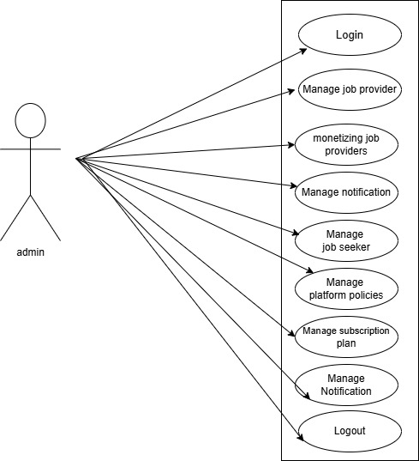

JOB PROVIDER

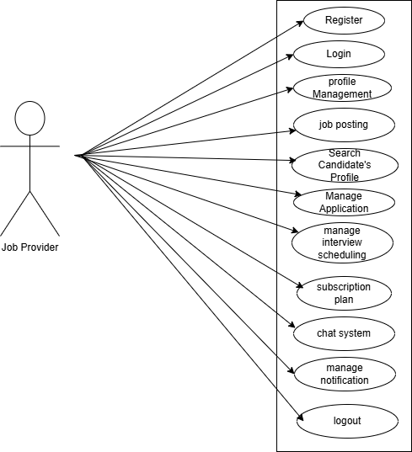

JOB SEEKER

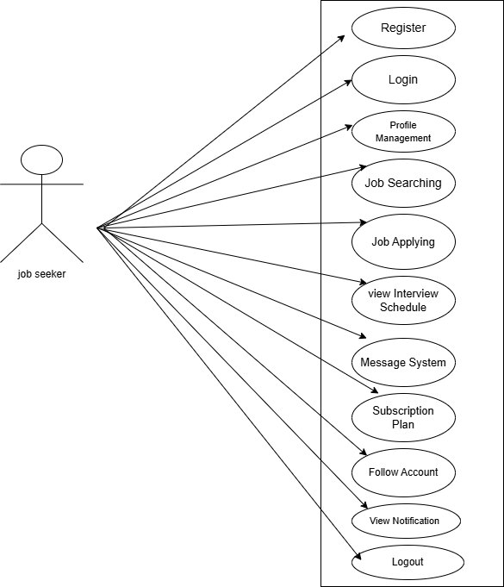

3.3 USE OF STORY

ADMIN

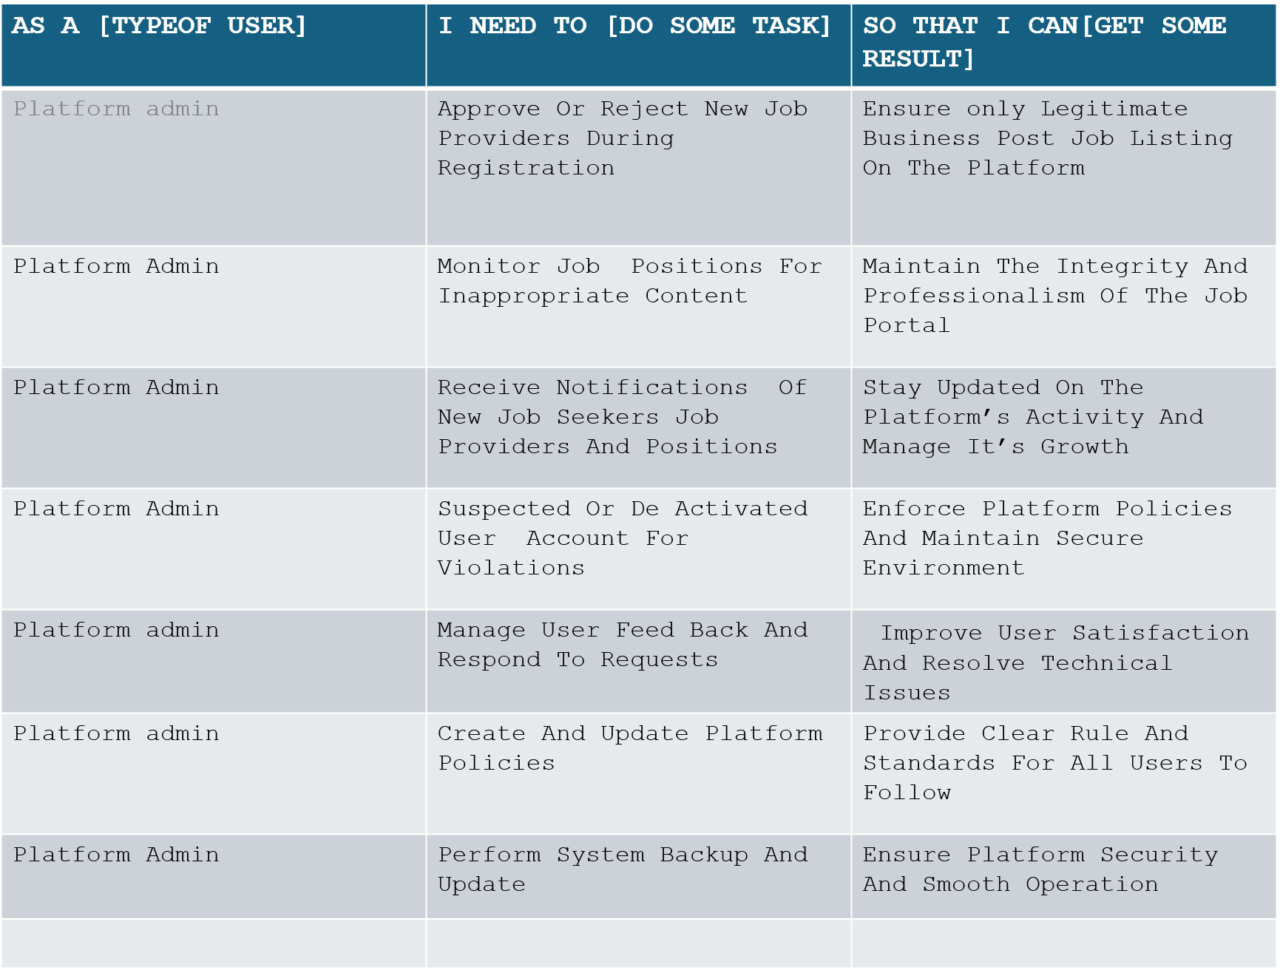

JOB PROVIDER

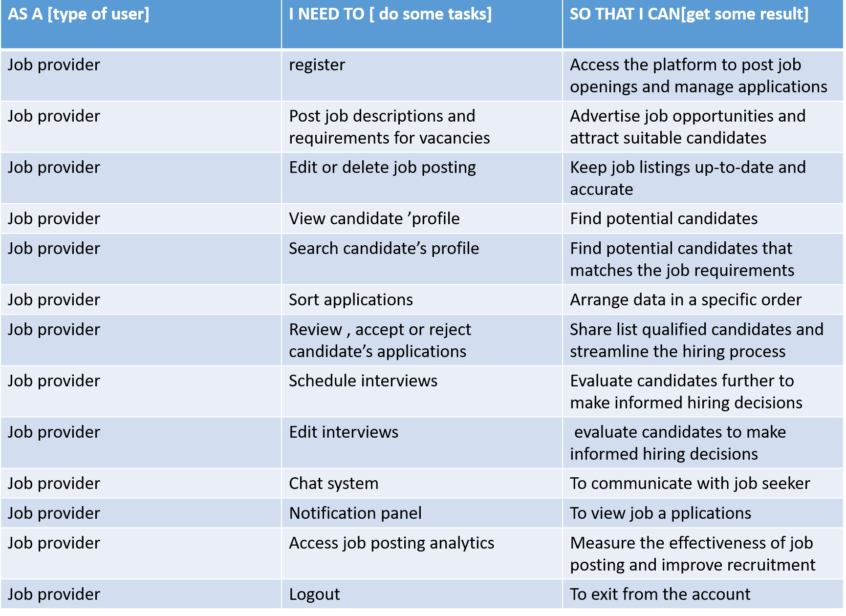

JOB SEEKER

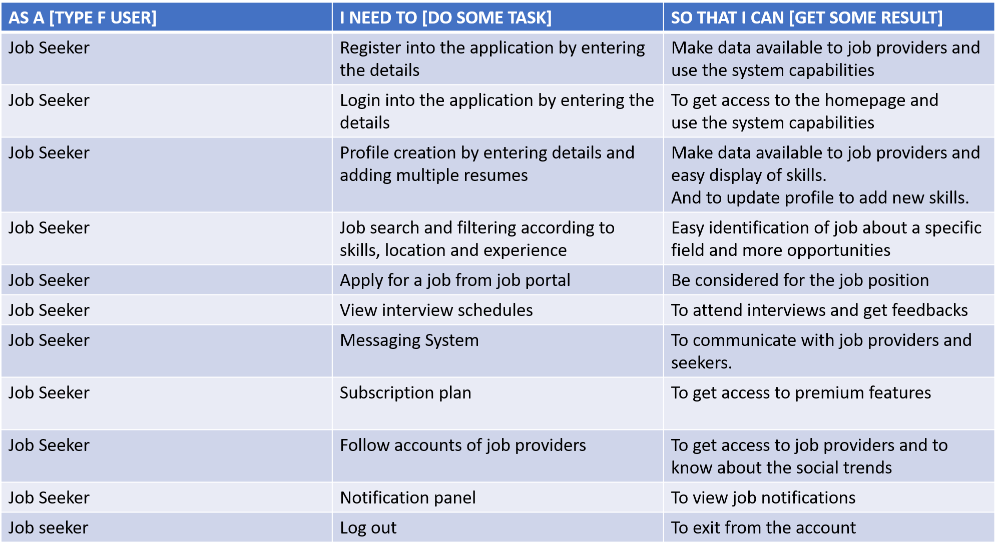

3.4 BPMN DIAGRAM

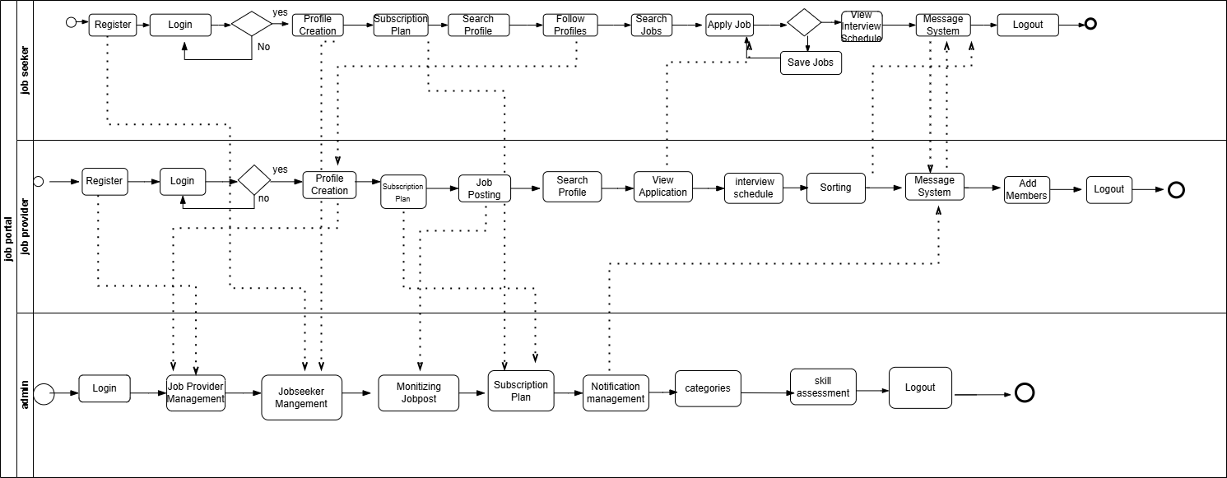

4 NON-FUNCTIONAL REQUIREMENTS

Non-functional requirements for a Job Portal System focus on the system’s performance, security, and overall user experience. The system must be **scalable** to accommodate a growing number of users, including job seekers, employers, and administrators, ensuring consistent performance even as traffic increases. **Response time** should be optimized to guarantee that users experience minimal delay when navigating the platform, searching for jobs, or applying for positions. The platform should also be **reliable**, with high uptime and backup mechanisms in place to prevent data loss and ensure continuous access to the portal. **Usability** is another critical non-functional requirement, meaning the interface should be intuitive, easy to navigate, and accessible to users with varying levels of technical expertise.

Security is paramount in a Job Portal System, requiring **data protection** mechanisms to secure sensitive information such as user profiles, resumes, and job listings. The system should implement **encryption** for data transmission and **strong authentication** protocols to prevent unauthorized access. Additionally, the system must comply with **privacy regulations** (such as GDPR) to protect user data and maintain trust. **Maintainability** is another key requirement, ensuring that the system can be easily updated and bugs can be resolved quickly. Finally, **compatibility** across various devices and browsers is essential for a smooth user experience, allowing users to access the portal from desktops, tablets, and mobile phones seamlessly.

Top of Form

5 TECHNICAL REQUIRMENTS

Processor :

Hard disk drivers: 320 GB

Memory

Operating SYSTEM : Windows 11

Front End : Html, CSS, Java script

Database :MSQL

Framework :ASP.NET

IDE : Visual

6. CONCLUSION

In conclusion, the Job Portal System serves as a comprehensive and efficient platform that bridges the gap between job seekers and employers, streamlining the recruitment process. By providing a user-friendly interface, advanced search filters, and real-time job matching, the system enhances the job search experience for candidates and simplifies the hiring process for companies. With features like resume management, job alerts, and personalized recommendations, the platform fosters a more dynamic and accessible job market, ultimately contributing to the growth and success of both individuals and organizations.